Self-Management Plan for Merge Details
Learn to understand what symptoms are normal for you and adjust your medication if they deteriorate.
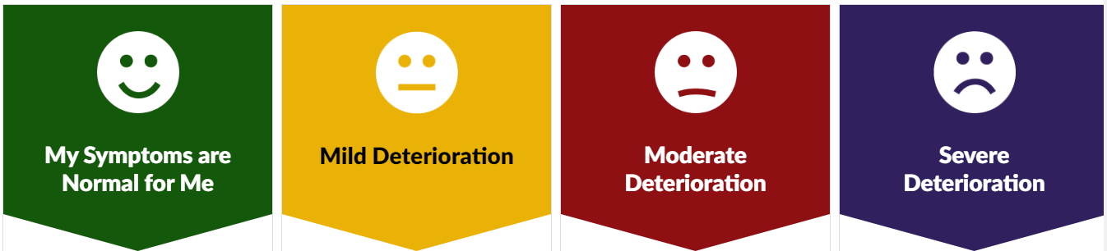

Learn to understand what symptoms are normal for you. Use your regular medication as prescribed by your doctor.
Remember inhaler technique.
When I Am Well
I will continue to take my regular medication which is:
Merge Regular Inhalers
I am more breathless than normal but have no fevers or change in sputum colour or volume.
When I Have Mild Deterioration
I will take my regular medication and use my reliever inhaler. My regular medication is:
Merge Regular Inhalers
My reliever inhaler is:
Merge reliever inhaler
I am more breathless than normal and coughing up more sputum or sputum has changed in colour. Or I am much more breathless despite taking my reliever medication.
I Have a Moderate Deterioration in My
Symptoms
I will continue to take my regular and reliever medication, and also take my rescue medication if there is no improvement within 2 days.
My rescue medication is:
Prednisolone5mg tablets - Take SIX tablets as a single dose EACH DAY for breathlessness
Merge ABx – ONLY TAKE IF SPUTUM CHANGES
My breathing is much worse than normal despite treatment or I have chest pain and/or high fevers.
I Am Much Worse Than Normal
I will call my GP the same day or call 999 if I am too unwell to wait to see my doctor. I will continue to take my medication as prescribed, which is:
Merge All Meds

