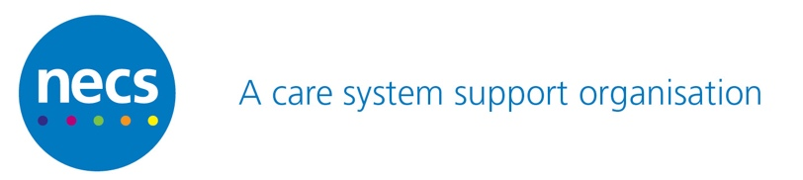

Use of cost-comparison charts to support prescribing cost savings.

Sources of cost-comparison data to help GP practices identify possible prescribing cost savings include Open Prescribing, Regional Drug and Therapeutic Centre (RDTC) cost comparison charts, and PrescQipp bulletins, amongst others.
The General Medical Council advises “As a prescriber, you are responsible for the prescriptions that you sign. You must only prescribe medicine when you have adequate knowledge of your patient’s health. And you must be satisfied that the medicine serves your patient’s need”.
While cost comparison charts can be very useful in identifying areas where savings can be made, the suggestions shown in the charts may not be therapeutically equivalent or used in the same way by the patient, as in the case of the thickener products shown in the illustration below (from Open Prescribing).
When using cost comparison data to identify savings, prescribers must ensure that any switches are safe and appropriate. In addition, prescribing choices should be in accordance with local formulary choices and guidelines except under exceptional circumstances where there is an individual patient clinical need.
Example: Open Prescribing. Under “Area and practice dashboards” for your practice:
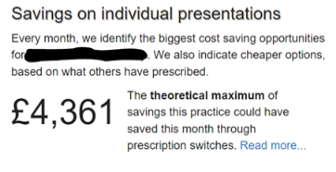
Clicking on the ‘Read more…’ link takes you to a list of items where savings could be made:
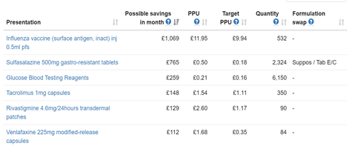
Clicking on individual presentations (in blue) gives further information about alternatives. Example below:
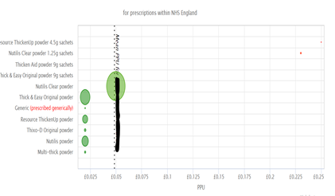
The thickener products shown in the charts are not equivalent, due to different formulation and instructions for use.

General Medical Council. Good practice in prescribing and managing medicines and devices. Accessed 13/12/2022. Available at <https://www.gmc-uk.org/-/media/documents/prescribing-guidance-updated-english-20210405_pdf-85260533.pdf>
North of Tyne formulary. Available at < http://northoftyneandgatesheadformulary.nhs.uk/about.asp> North Cumbria guidelines are available at <https://medicines.necsu.nhs.uk/guidelines/cumbria-guidelines/>

